# Exercise: Introduction to Bootstrap

Problems for exercises and homework for the ["JavaScript For Front-End Course @SoftUni"](https://softuni.bg/trainings/2032/javascript-for-front-end-july-2018#lesson-8965).

Archive your solutions and upload them in [course page](https://softuni.bg/trainings/2032/javascript-for-front-end-july-2018#lesson-8969).

## Bootstrap Website

You are given the **images** and **text**. Your task is to create entire website with **Bootstrap**. You are **NOT** allowed to use jQuery or Bootstrap plugins but you should write some custom **CSS**. Your **project structure** should look like this:

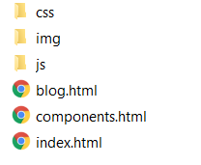

The **home** **page** should looks like this:

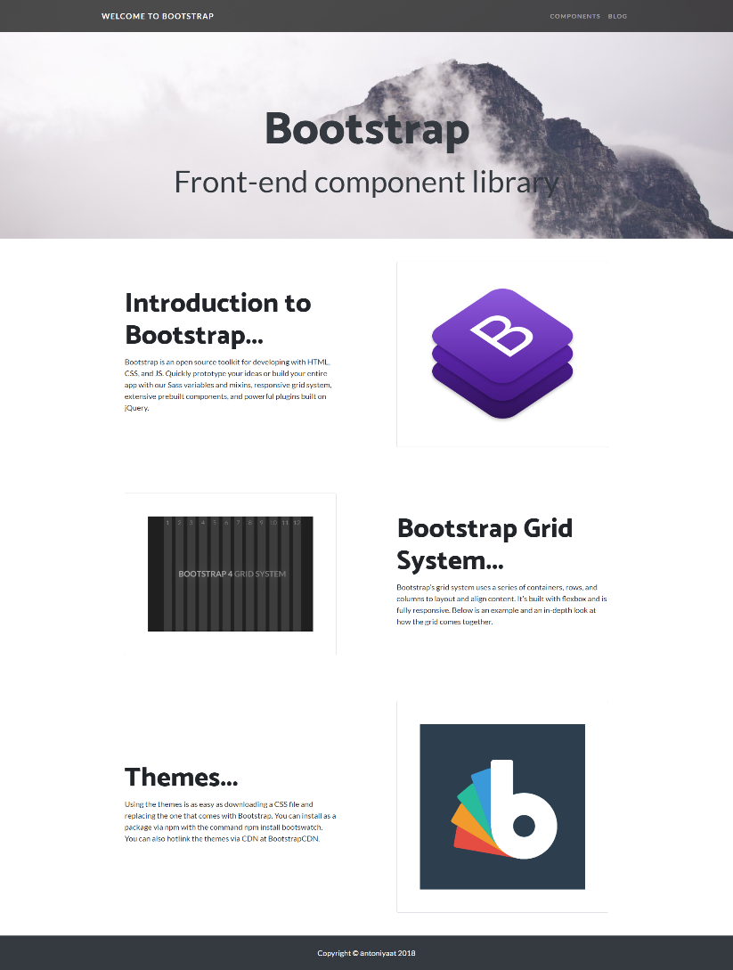

The **components** **page** should looks like this:

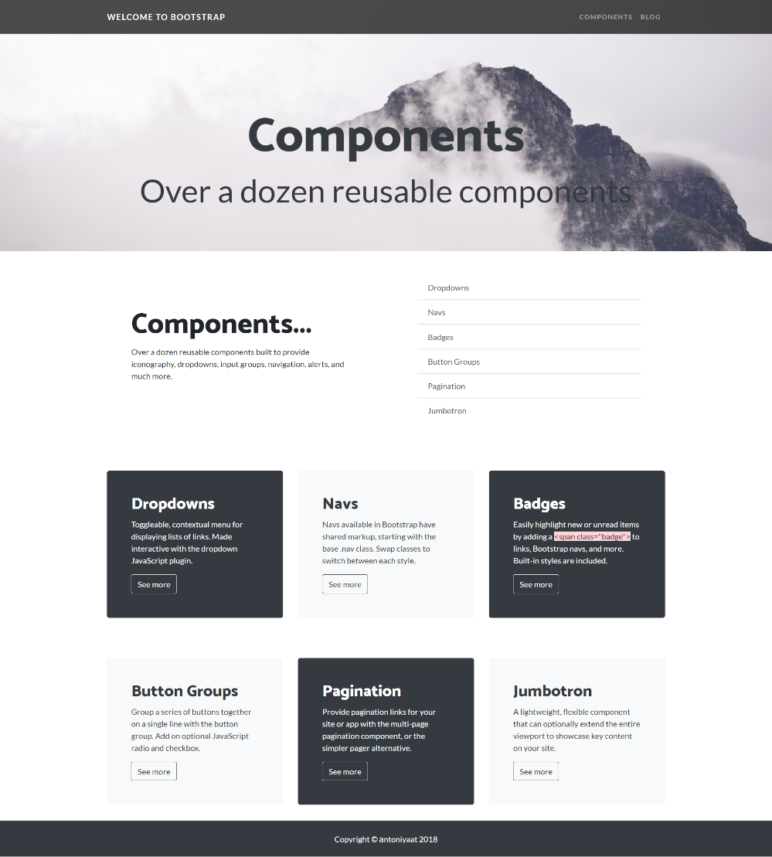

The **blog** **page** should looks like this:

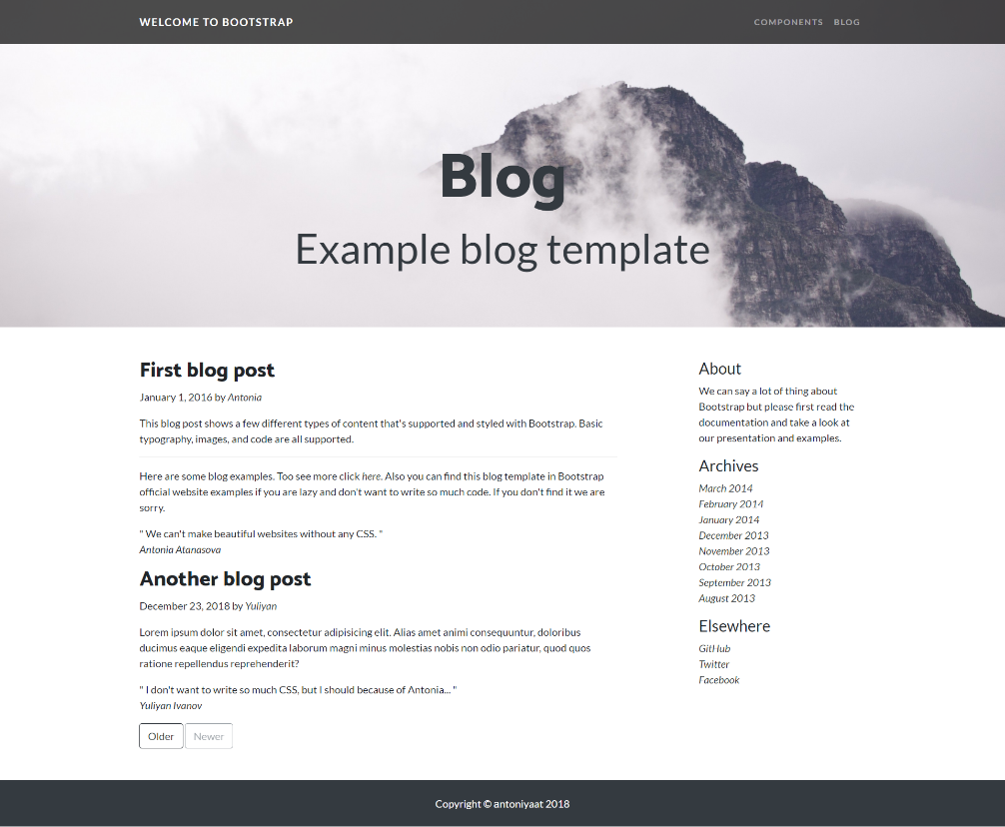

Your website should have three pages and navigation **between** them.



## Constraints:

* Use “Lato” for **main font** – <https://fonts.google.com/specimen/Lato?selection.family=Lato>
* Use “Catamaran” for **headings**  (**font-weight:800**) – <https://fonts.google.com/specimen/Catamaran?selection.family=Catamaran>
* Use background-color: **#343A40**
* Make sure that your website is **responsive**

## Hints:

* You can reuse **navigation bar** and **footer**
* You can search for **Blog** **Example** on **Bootstrap** official documentation
* Import **fonts** at custom **CSS** file
* Style heading with image for background in your **custom CSS**